FFT in excel:

# Inputs:

The inputs must be in separate columns containing the time, X -Axis and Y -Axis data. Like this:

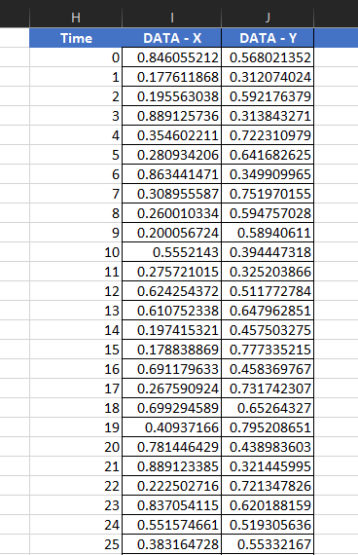

# Data analysis pack:

For calculating FFT in excel we must add the File -> Options -> Add-Ins -> Manage: Excel Add-Ins -> Go

Then choose the ‘Analysis ToolPak’ and then install.

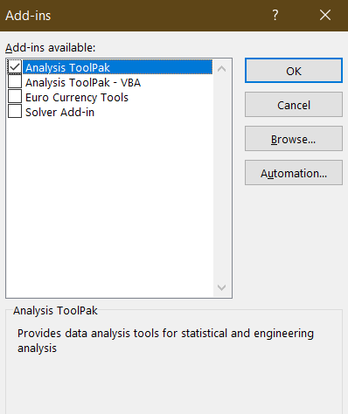

# FFT:

For applying FFT, we must select the Data Analysis tool in Data menu. In the pop-up window, we must select the input data for which we want the FFT. The number of elements must be in powers of 2 for the function to work. We must also select where we want to paste the FFT results. After choosing both, the menu looks like this:

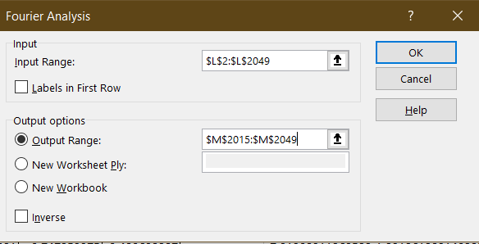

# Frequency range:

The frequency is related to the sampling frequency and the number of samples. The time of each sample is divided by N/Fs, where N is the number of samples and Fs is the sampling frequency. When each value is divided by this term, we get a column containing all frequency ranges required.

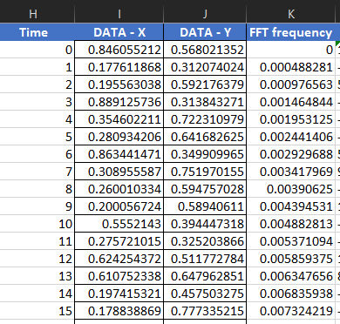

# Magnitude of fft:

The plot should show the magnitude of each frequency, so we must the absolute value of the data and then plot it against the frequency.

To take the absolute value of the imaginary value, the function IMABS() is used. The function is applied on one cell and then dragged all the way to the end so, it is applied on the values. After this the sheet looks like this:

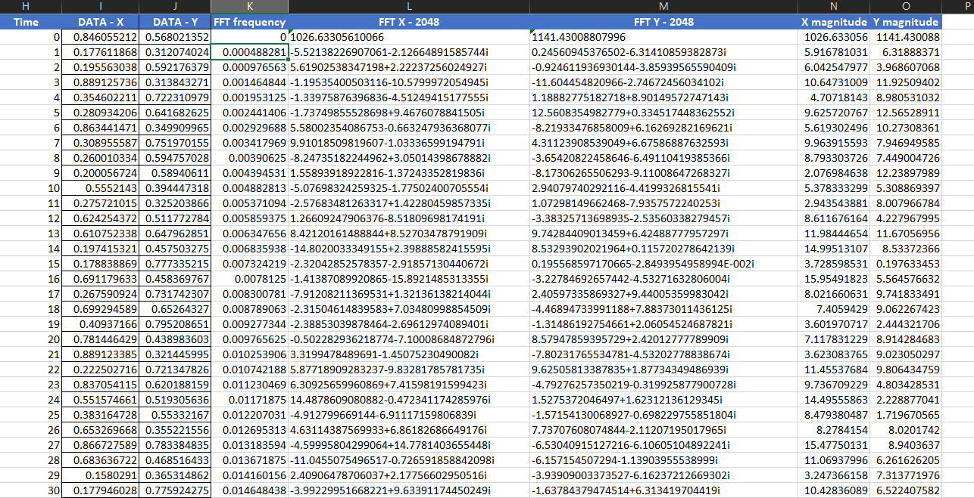

# Plot:

The frequency spectrum is obtained by plotting the X and Y magnitudes vs the frequency. The desired plotting style can be chosen from the Insert Chart menu. The final output looks like this.

